|  |  |
| --- | --- |
| **Team Member Name:** | **Team Member UID:** |
| Manish Shashikant Jadhav | 2023301005 |
| Mayur Krishna Solankar | 2023301018 |

|  |  |
| --- | --- |
| **EXPERIMENT**  **NO:** | 5 |
| **AIM:** | Data Flow Diagram(DFD) for Hostel Management System. |

The Hostel Management System (HMS) project addresses the challenges faced in efficiently managing hostels in today's

world. With a focus on enhancing student satisfaction, the HMS aims to provide a comprehensive solution. It offers user management for administrators, students and visitors, simplifies room booking, facilitates smooth check-in/check-out processes, manages billing and payments, monitors room availability, maintains student profiles, and provides reporting and analytics tools. The system ensures data security and privacy compliance while offering a user-friendly interface accessible via a web app. By automating administrative tasks and optimizing room management, the HMS benefits hostel owners, while also improving the student experience and modernizing hostel operations.

**Problem Statement:**

# DFD for 0 level :

The context diagram is an alternative name for the Hostel Management System DFD

Level 0. Users, the main process, and data flow make up its parts. Also, the project concept is demonstrated using the single process visualization.

DFD Level 0 shows the entities that interact with a system and defines the border between

the system and its environment. This diagram also depicts the hotel management system at a high level.

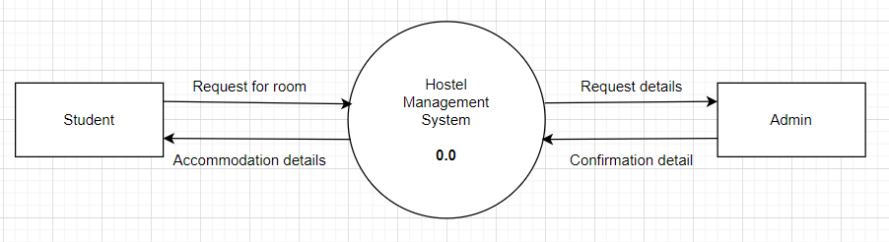

The illustration presents the main process in a single node to introduce the project context. This context explains how the project works in just one look. The user feeds data into the system and then receives the output from it.

# DFD for 1st level :

The "detonated view" of the context diagram is Hostel Management System DFD Level 1. Its function is to deepen the concept derived from the context diagram.

Specifically, level 1 shows the broader details of Hostel Management System DFD Level 0. This is to clarify the paths (flow) of data and its transformation from input to output.

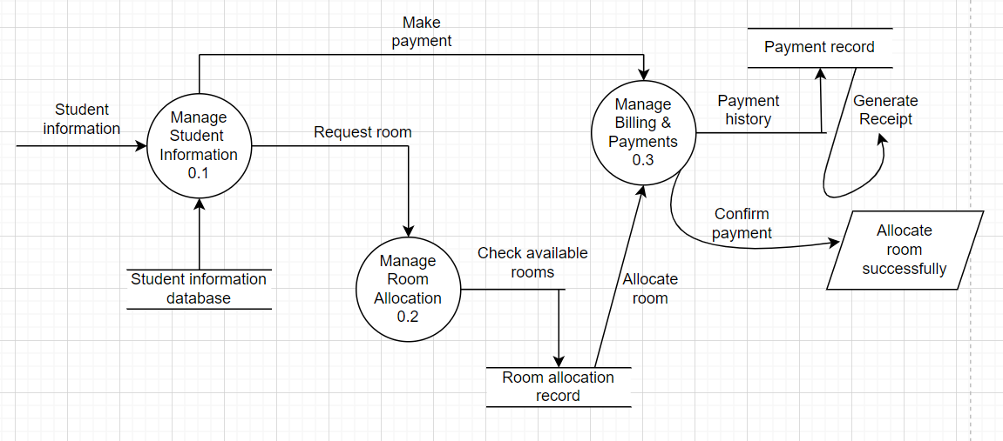

The designed diagram portrays different scenarios: Student information Management, Hostel room allocation, payments management and Transaction reports.

# Structure chart for 1st level :

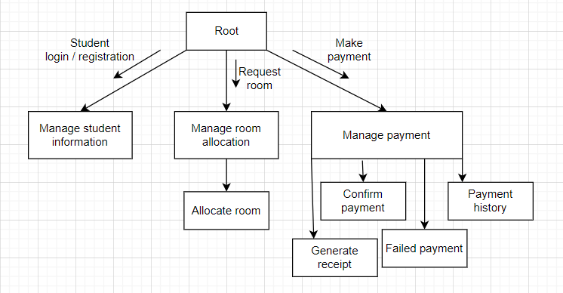

Here is the structure chart for DFD 1st level. It shows transaction analysis as well as transformation analysis. From the root, we can see that there is no single input in the Hostel Management System, therefore transaction analysis is used here; And further it divides into

transformation analysis where every process gives only one possible output except the Payment management.

# DFD for 2nd level :

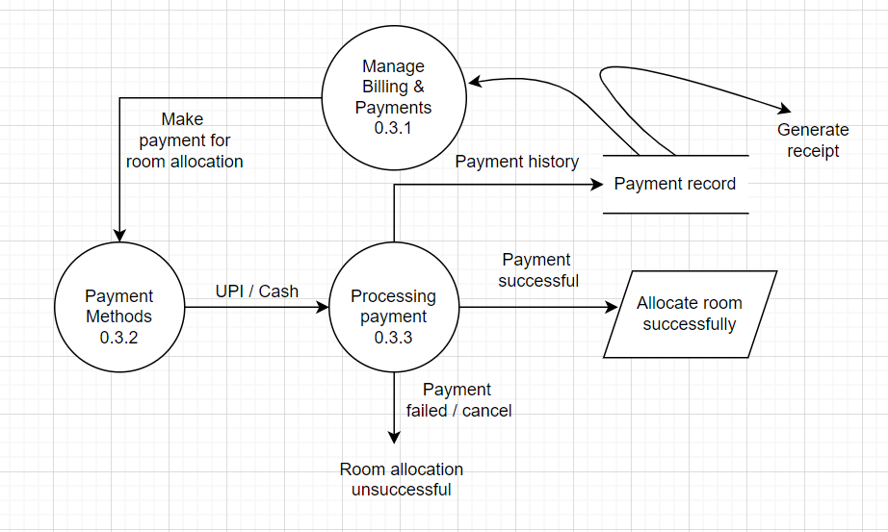

Hostel Management System DFD Level 2 is also the highest abstraction of the data flow diagram. This level also broadens the idea from the DFD level 1. It includes the sub-processes from level 1 as well as the data that flows.

Here, we have discussed only the Billing & Payment Management (0.3) from the DFD level 1. We expand this process into further processes : Payment methods and Processing payment.

# Structure chart for 2nd level :

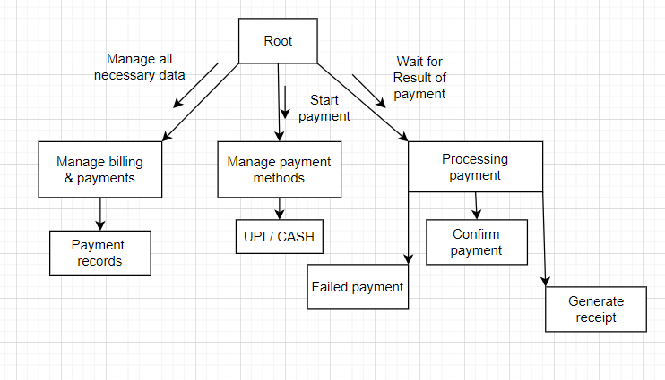

Here is the structure chart for DFD 2nd level. It shows transaction analysis as well as transformation analysis. From the root, we can see that there is no single input for the Payment Management in Hostel Management System, therefore transaction analysis is used here; And further it divides into transformation analysis.

# Data Dictionary:

1. **Entities:**

Students:

Room:

* Student ID: Unique identifier for the student. (String)
* name: Name of the student. (String)
* contactNumber: Contact number of the student. (String)
* address: Address of the student. (String)
* checkInDate: Date when the student checked in. (Date)
* checkOutDate: Date when the student will check out. (Date)
* roomNumber: Unique identifier for the room. (String)
* capacity: Maximum number of occupants for the room. (Integer)
* isOccupied: Indicates whether the room is currently occupied or not. (Boolean)

Billing:

* + billID: Unique identifier for the bill. (String)
  + studentID: Identifier linking the bill to a specific student. (String)
  + amount: Total amount to be paid. (Double)
  + isPaid: Indicates whether the bill has been paid or not. (Boolean)

1. **Processes:**

Manage student Information:

* + - Inputs: student Information
    - Outputs: Updated student Information Manage Room Allocation:
    - Inputs: student Information, Room Availability
    - Outputs: Room Allocation Details Manage Billing and Payments:
    - Inputs: Room Allocation Details, Billing Information
    - Outputs: Payment Records, Updated Billing Information

1. **Data Stores:**

**Student Information Database:**

* + - Description: Database storing information about hostel Students.
    - Attributes: StudentID (String), name (String), contactNumber (String), address (String), checkInDate (Date), checkOutDate (Date)

**Room Information Database:**

* + - Description: Database storing information about hostel rooms.
    - Attributes: roomNumber (String), type (String), capacity (Integer), isOccupied (Boolean)

**Billing Information Database:**

* + - Description: Database storing billing information for hostel Students.
    - Attributes: billID (String), StudentID (String), amount (Double), isPaid (Boolean)

**Payment Records:**

* + - Description: Records of payments made by Students.
    - Attributes: billID (String), paymentDate (Date), paymentAmount (Double)

# Conclusion:

In conclusion, a well-constructed DFD for a Hostel Management System helps in understanding the information flow and interactions within the system. It simplifies complex processes, making it easier to identify errors, or areas for optimization. By visually mapping data movement, it aids in system design, analysis, and communication among stakeholders, ultimately contributing to more efficient and effective hostel management. Also it includes the Structure Chart diagram for level 1 and level 2 of DFD which helps to identify the basic structure of the given system.At last, we have created a data dictionary which provides a clear definition of the data elements used in the hostel management system, including entities, their attributes, processes, and data stores.